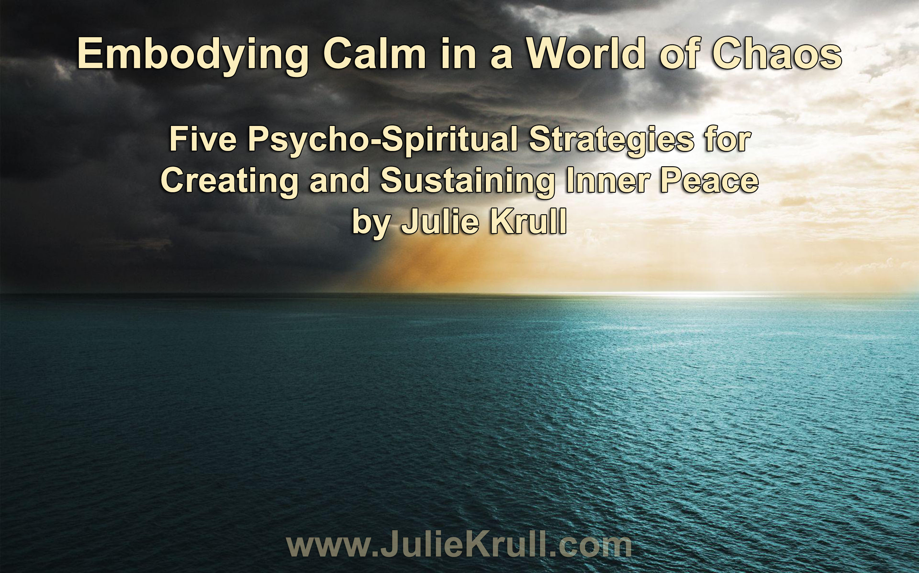

- Learn the subtle art of shifting your reality and the illusion of separation
- Discover and clear the unconscious ways you create more chaos
- Create more calm in your body, mind, spirit and life

Twenty years ago, I remember (so well) watching the hit movie, Twister, when it came out in the theaters. It was a complete, adrenaline-filled, tense and NOT-so-relaxing one-hour-and 53-minute-experience for me. There were many scenes of devastating, destructive storms as the main characters were storm chasers tornados doing research. Dark clouds, high winds and flying debris were common scenes in the movie. Set in a rural area, the flying tractors, semi-trailer trucks, combines, and miscellaneous farm equipment were familiar to my eye.
A few specific moments in the movie created a big impact on me. First, among the plethora of flying debris, the special effects managed to capture what appeared to be a real, living cow flying through the sky, moving effortlessly across the big screen as the tornado lifted it and propelled it through the air. The odd image burned a poignant memory in my mind.
The other powerful moment was the finale when Helen Hunt and Bill Paxton, stars of the film, strapped their bodies to an irrigation-well, in a pump house, during the largest and final storm of the movie. In a crescendo of suspense, fear, chaos, and extreme danger, the loud, black storm moved over them, tearing off all remnants of the shed and leaving them at the mercy of the leather straps secured to the metal pipe. As the tornado moved directly over them, there was an incredible moment where they – with their inverted bodies that had lifted in the wind – had the realization that they were in the eye of the storm. They both looked up and saw a beautiful blue sky in the center of the black, spiraling wall clouds. An eerie sense of calm overcame them.

The moment was brief and fleeting. The producers perfectly placed some uplifting “heavenly” background music for the climax of the film. As a stressed-out, tense audience member, I knew everything was going to be okay. An overwhelming sense of peace washed over me. My body relaxed and I felt calm again. The blue sky (and music) was enough to physiologically reverse the stress response I felt in my body.
This scene inspired and intrigued me. Cinema is so powerful. An imaginary story, told with multisensory genius, got me so caught up in an emotional stress response. And a few simple shifts changed everything so dramatically.
Back in 1996, as a psychotherapist, I was teaching clients how to achieve inner peace, and here was a great, real palpable example of what I was teaching. So often, we feel ourselves get caught up in the tornado-like chaos spinning around us. No matter how hard we try, the emotional debris of stress, trauma, loss, and life’s ups and downs, can literally sweep us up into even greater chaos. But most often, it’s the small storms of everyday life that keep us in chronic stress.
There was more than just the “special effects” of the movie that gave me insight. It was the tornado, itself. Nature’s design is so powerful. I often go to nature for examples and wisdom. Nature can teach us so much if we just tune in and pay attention. I believe almost every solution to problems we face can be found in the organic, natural world as it unfolds, moves, grows, seasons, regenerates, and creates itself before our eyes. Nature shows us sacred geometry, cycles, patterns, and natural law.
Like the tornado, the eye of a hurricane, or a tropical storm, is a great example of calm within the chaos. The eye is a region of mostly calm weather at the center of strong tropical cyclones. The eye of a storm is a circular area, typically 20 to 40 miles in diameter. The “eye wall,” a ring of towering thunderstorms where the most severe weather occurs, surrounds it. In strong tropical cyclones, the eye is characterized by light winds and clear skies. One can even see the sun shining in the center of a devastating hurricane. Seriously. One can experience sunny skies and calm winds in the center of a cyclone.

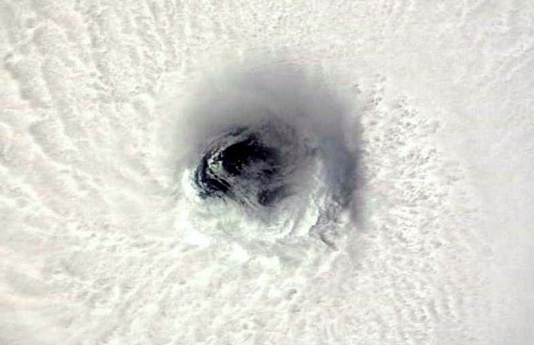

So how do we, as humans, create and sustain calm in the middle of chaos? How do we achieve inner peace and develop practices to enhance our ability to maintain a clear, calm center that actually keeps the storms of life at bay?
In this document, I share five strategies that will assist you in making the psycho-spiritual shift from a storm-centered focus to a calm way of being. These strategies work with your body, mind and spirit. They address not only the micro perspective of your cellular biology, but expand out to a macro perspective of the global shifts and transformation occurring on our planet.
This is not a substitute for good stress management tools and techniques. If you are prone to severe anxiety, panic disorders, or depression, many medical and mental health practitioners can give you responsible, holistic care. However, the following five strategies are real life-changing practices that I use and teach others to explore. To create and sustain lasting change in our personal lives and in our world, it is essential that we understand this next stage of the evolution of consciousness. Our ability to shift our perspective, embody joy, merge with Creative Intelligence, hold the field, and serve others from that place is a treasure map that carries infinite creative potential and healing. I call them psycho-spiritual strategies because we begin with the perspective of the soul, or higher self. Our treasure map takes us from our mind and expands out to our service of others:

- Create Peace of Mind: Shift into a Mental Calm by Understanding the Illusion of Separation
- Discover a Relaxed Mind/Body: Experience Physical and Emotional Calm, Therapeutic Breathing and Heart Resonance
- Surrender into a Spiritual Calm: Achieve Unity Consciousness by Tapping and Trusting the God Source Consciousness Within
- Carry Peace With You: Learn to Expand and Hold a Field of Calm Wherever You Go
- Realize Peace on Earth: Participate in Global Shifts Toward a Calm Understanding that Breakdowns Lead to Breakthroughs

The principle in the first strategy is foundational for the rest. In fact, the strategies are all important in themselves, yet build on one another and interweave in creative and sustainable ways. Play with your own understanding and interpretation of the strategies. Allow your life experience to ping off any universal truths that move you or incite your curiosity. If you aren’t resonating, that’s okay. Consider that what wants to grow will be seeded. Breathe. Relax. And Enjoy.

- Create Peace of Mind: Shift into Mental Calm by Understanding the Illusion of Separation

Let us start with an important concept and realization. I usually go back thousands of years and discuss the evolution of consciousness, our human species, and the theories and stages of cognitive, psychosocial, emotional, ego, faith, and moral development. However, for the sake of brevity, we’ll begin much simpler. Let’s play with the idea that we are a developing species, open to growth, change and maturation.
As we become self-reflective, we begin to look outside of ourselves to find our place in the world and within our tribe. We learn about ourselves in relationship to others. That outward focus begins a process of comparing and contrasting. We begin to look toward others to see and experience ourselves as separate beings. On our journey toward self-actualization, we stop, check-in and see how we measure up. It’s a healthy part of developing the individual self. How are we different? How are we the same? What can we do well and not so well? How do we think? What do we believe and value? What are our gifts and abilities? What makes us unique? What’s our soul’s purpose?
As humanity, we have mastered this important stage of development.
Yet, our consumer-driven culture often creates an added layer of stress and anxiety. As we look outward, comparing and contrasting, popular culture and the media has created unrealistic expectations of how we define and achieve success, beauty, wealth and the pursuit of happiness. Instead of self-actualization, we have pushed ourselves into an endless cycle of competition and conflict, where we can never win or relax into our being.
Our desire to achieve success and wanting to “fit in” or “get ahead” leaves us feeling broken, confused, empty, craving more, and most importantly “alone” and separate. With this skewed measure stick, we will never measure up. We have fallen into an abyss of harsh judgment and criticism – of others and ourselves. Striving for perfection, we endlessly fall short. We never have enough or are enough. Beauty standards are horribly dysfunctional and unhealthy at best. Consumerism has us swimming in debt and/or working harder. We keep running faster and faster into the cultural rat race and find ourselves on the proverbial hamster wheel, going nowhere.
Seeing ourselves as separate from others helps us develop our individual, unique gifts and talents. However, it has created an illusion of separation that is killing us, as individuals and a species. We have seen ourselves separate from the earth, nature, God/Creator/Source, and one another. It is now time to remember who we really are.
Science, Quantum Physics, religion, and spirituality all demonstrate our interconnected reality and oneness. Not only are we one, interdependent living system, we are learning more about collective consciousness, energy fields and our cosmic connection. Holism, Integral Theory, Epigenetics, Energy Psychology, Quantum Physics, Fractals, Holons and Holographic Principles, String Theory, Conscious Evolution, Unified Theory of Everything (and the list goes on)… we are just beginning to understand our interconnected nature and what we know is the tip of the iceberg. New scientific discoveries parallel ancient spiritual teachings. Comprehending how all things are connected changes everything. Lynne McTaggart agrees:

“The implications of this new story to our understanding of life and the design of our society are extraordinary. If a quantum field holds us all together in its invisible web, we will have to rethink our definitions of ourselves and what exactly it is to be human. If we are in constant and instantaneous dialogue with our environment, if all the information from the cosmos flows through our pores at every moment, then our current notion of our human potential is only a glimmer of what it should be. If we’re not separate, we can no longer think in terms of “winning” and “losing.” We need to redefine what we designate as “me” and “not-me,” and reform the way that we interact with other human beings, practice business, and view time and space. We have to reconsider how we choose and carry out our work, structure our communities, and bring up our children. We have to imagine another way to live,”

Imagining another way to live, and be in relationship with each other, is at the heart of creating peace. When we truly see ourselves as valuable and necessary wholes within the whole of community, the world, and our universe, we can relax and let go of our perceived deficits. We can stop judging and step out of the need to “keep up” or compete. We discover ways to cooperate, collaborate, and co-create. We find value in our differences and strive for harmony, resonance and celebration of the diversity. We stop fighting with and killing others who don’t think, believe, and value what we do.

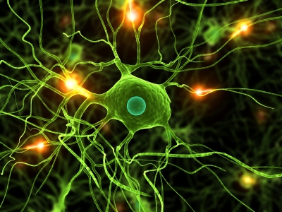

Just like individual cells in the human body all have their unique role and function, we too are individual cells in a larger, unified body – with a unique role and function. We differentiate only to loose ourselves in the greater good of the whole. Heart cells within the human body don’t judge, compete with or destroy other cells within the body. They simply do their individualized part while performing a function for the whole.
Thich Nhat Hanh says, “True self is non-self, the awareness that the self is made only of non-self elements. There's no separation between self and other, and everything is interconnected. Once you are aware of that you are no longer caught in the idea that you are a separate entity.”
“You are not a separate entity.” Some say we are drops of water in the great ocean. Others say we are individual branches on a tree. And even others say we are a holons – simultaneously a whole and a part of Creation itself. We are simultaneously a separate self, expressing, and the unified, spiritual essence of the greater whole.
Our Separate Self is the ego, personality, and individually gifted, finite, unique expression. When we experience life through the lens of the Separate Self, we tend to be in that place of comparing, contrasting, competing and conflicting. We analyze, judge, and measure. The separate self is motivated toward “what is in it for me?” The focus can be “survival of the fittest” and self-preservation. Separation consciousness often creates stress, limitation and constriction as we get caught up in proving our value to others and ourselves.
Our Unified, Essential Self is the essence of who we are and be, as the infinite, limitless expression of all that is. Experiencing life through this lens, we tend to gravitate toward resonant relationships, cooperation, and others with unity consciousness. We value community and communion and naturally work together. Our motivation is looking for how we might serve the greater whole and larger purpose. The focus is serving the “least of these” because we know they are a part of ourselves. Unified consciousness introduces an open, limitless, expansion of self in the world. We see value in others and ourselves. There is no need to prove anything.
By understanding the illusion of separation, we shift into our essential selves and open to a natural state of relaxation and peace. It reminds me of a poem by Thich Nhat Hanh:

Be yourself.
Life is precious as it is.
All the elements for your happiness are already here.
There is no need to run, strive, search or struggle.
Just Be.

Just be. Be the calm. Be the peace. Be the precious life that you are.
This brings me back to the eye of the storm. Imagine the tornado or hurricane as the separate self or ego getting caught up in the need to fit-in, compete, or get ahead. The dark swirling clouds of fear and anxiety are the result of limiting thoughts and beliefs. Imagine, almost all of the storms of life that blow through, are the result of seeing ourselves as separate. The storm is the competition, chaos, and conflict that come with the illusion. Step out of the storm. Step through the illusion. Intentionally and consciously choose to move yourself into the calm center with a higher perspective. In the center, you will discover the essential self connected to all things. From this vantage point, you know the dark clouds swirling around are simply a temporary, illusory storm that will eventually blow through or dissipate.
We all have the capacity to center ourselves and find the calm of inner peace. Even when those around us are caught up in their own self-induced tornados, we can stay in the eye where the sun is shining and the birds are singing. Go to center. Practice. When you witness discordant energy in yourself or others, ask yourself how the illusion of separation is creating chaos in that moment. The more you observe yourself inside the storm, the easier it becomes to step out and stay out – for good. Begin looking around and pay attention to the storms of life. Watch movies, read stories, listen to others, and follow the news, if you must. The more you open yourself to this new perspective, the easier it is to see it manifesting everywhere.
For more on our interconnected lives and Universe, tune into The Dr. Julie Show: All Things Connected where we host visionary leaders and change-makers, in nearly every field, to talk about this planetary shift into unity consciousness.

- Discover a Relaxed Mind/Body: Experience Physical and Emotional Calm, Therapeutic Breathing, and Heart Resonance

When you master the cognitive shift in perspective it will be easier to relax your mind and body as well. There are many mind/body techniques to elicit the “relaxation response” – a physical state of deep rest that changes the physical and emotional responses to stress and relieves/reverses the body’s fight or flight response. The relaxation response was first coined by Herbert Benson, M.D. , a pioneer in mind/body medicine. And now there are myriad holistic options and practices available.
Almost all relaxation techniques start with the breath. Conscious breathing and deep breathing techniques can change your life. Breathing is essential to life and good health. Practicing conscious breathing can improve sleep, reduce stress, and boost your overall health. Simply learning to take therapeutic breaths throughout your day can alleviate many common health ailments, including high blood pressure, migraine headaches, anxiety, stress, chronic pain, depression, asthma, and insomnia.
Deep breathing naturally brings us into our “center” and elicits the relaxation response. It moves us out of our minds and thoughts and into our bodies, unifying our mind/body/spirit. Anytime we can slow down and focus on our breath we are practicing good medicine and it dispels another layer of the illusion of separation from our bodies. We can literally experience our consciousness shifting our mind and body instantaneously. It also induces a state of coherence and heart resonance.
Some of the most exciting techniques and evolutionary practices in relaxation and heart resonance are coming from the emerging science of the HeartMath Institute. HeartMath’s purpose is to provide “tools that connect us with the heart of who we truly are for living healthier, fulfilling lives and building a brighter future.” Since the early 90s, the institute has researched and developed reliable tools that help bridge the heart and mind. We are learning so much about heart intelligence, coherence and resonance from them.
What I appreciate most about HeartMath is how they developed an approach that naturally and efficiently calms the mind. By focusing on the heart, the mind quiets and comes into coherence with the heart. There’s no need to think, or not think, in order to meditate and relax. Their Quick Coherence Technique easily creates a state of coherence in about 60 seconds by releasing stress and draining emotions. When you learn how to amplify heart coherence, the heart and mind create a coherent state together. Thoughts and emotions balance and you experience a deep relaxation, inner peace and harmony. This also helps us access our heart’s intelligence, creativity, intuition, and higher-level decision-making.

There are three simple, proven steps to the Quick Coherence Technique. Step One: Heart Awareness – Focus your attention into your chest in the area of your heart. Step Two: Heart-Focused Breathing – Imagine your breath is flowing in and out of your heart or chest area, breathing slower and deeper than normal. Step Three: Activate a Positive Feeling – Recall a time when you felt great joy, appreciation, or deep love for someone or something in your life. Really feel the feeling as if it were occurring right now. That’s it! The benefits are beautiful. Here’s a brief 3 ½ minute audio of the technique that explains it and guides you in the exercise: Quick Coherence Technique for Adults. There are many other audio and video resources you can find on the Internet.
Learning to practice coherence together in groups is quickly becoming a practice recognized to increase resilience in organizations, improve group performance, and transform the workplace. It is being taught in hospitals, schools, churches, and a variety of organized heart-centered initiatives and platforms.

- Surrender into a Spiritual Calm: Achieve Unity Consciousness by Tapping and Trusting the God Source Consciousness Within

Many believe there is a Universal Life Force, a Creative Impulse, Designing Intelligence, or Pure Source Consciousness that resides within every living thing. Some call it Allah, Father, God, Great Spirit, Creator, Source, Love, your Higher Self or the Great I Am. There are many names and no names for The Benevolent Creative Force. No matter how you see the Infinite, Spiritual Essence and Divine Wisdom, most agree their limited, finite mind can not comprehend the magnitude, depth, breadth and multi-dimensionality of this designing God Source of the Universe.
The same innate Designing Intelligence and Consciousness that blooms a flower lives inside a migrating bird or a salmon swimming upstream. It’s the same Divine Wisdom that heals our bodies and guides the seasons. It’s the same Creative Impulse that inspires great music, poetry and art.
Trust that Intelligence.
Along with the HeartMath resource listed above, there are many powerful practices that teach us how to tap into the God Source Consciousness within. Many forms of meditation, dedicated quiet time, prayer, and centering techniques access the same genius. There are three primary types of meditation: 1. Focused attention on a single object (breath, mantra, word, visualization, talisman, etc.); 2. Open monitoring focuses on the experience of the mind and whatever comes into the awareness without judgment of attachment; and 3. Emptying or creating a void of nothingness that trains the mind to be still.

There are dozens of different meditation disciplines. It’s important to find one that fits your personality and temperament. The best meditation is the one that works for you. You have likely heard of these familiar meditation types: Buddhist, Loving Kindness, Metta Chakra, Kundalini, sound, mantra, pranayama, Qigong, Mindfulness, Vipassana, Taoist, Zen, Vedic, Yogic, OM, Walking, Transcendental, and Christian Contemplative. There are many more meditation types within the main branches and traditions.
Centering Prayer, was introduced by Father Thomas Keeting. It is described as, “a method of silent prayer that prepares us to receive the gift of contemplative prayer, prayer in which we experience God’s presence within us, closer than breathing, closer than thinking, closer than consciousness itself.” This method of prayer is both a relationship with God and a discipline to foster that relationship and moves one beyond conversation to communion.
We contrast this with other types of meditation that don’t focus on a relationship with God, but more on accessing a field of pure consciousness. Transcendental Meditation ™ is a technique that allows your mind to easily settle inward, through quieter levels of thought, until you experience the most silent and peaceful level of your own awareness — pure consciousness.
Practicing meditation is one path to accessing the still point inside. Yet other paths are practicing a moment-by-moment communion and prayer conversation with the internal guidance of Source. Learning how to ask questions and listen for the myriad answers in subtle feelings, intuition, voice, symbols, or psychic and energetic responses. We are developing a powerful internal GPS of the Soul. And this GPS is as different as the 7 billion people on the planet. Again, the best way is the way that works for you.
Tap this Infinite Source and learn to trust your experience. Follow the threads. Trust the synchronicities. Open yourself to the possibilities. Begin to experience this Wisdom as a part of yourself. Going back to the “Illusion of Separation,” we tend to believe the Source is somewhere “out there” and we have to work hard to create or maintain a connection. Yet, it is as simple as tuning into a frequency, like turning a knob on an old transistor radio. The Wisdom is always there, broadcasting. It is up to us to access and trust what we receive. In doing so, we create a breadth and depth of confidence.
This intimate relationship with God Source Consciousness gives us a deeper sense of spiritual calm. We learn to rest in a beautiful field of knowing, depending less and less on the torrent winds of ego, the transient storms, and external stimulus. We become so grounded in the eye of the storm, that we rarely notice any storms at all – even those of others. This spiritual calm becomes our new way of being. Next, we desire to expand that peaceful core, carry it with us, and share it with others.

- Carry Peace With You: Learn to Expand and Hold a Field of Calm Wherever You Go

Once we learn to go to center and realize the calm of inner peace, practice embodying it in our physical bodies, and trust our ability to access a deep well of Source Intelligence within, its time to hold this profound serenity, expand its influence, and carry it with us wherever we go.
Holding this frequency of inner peace becomes tangible and noticeable to others. We all know of persons who carry a radiant glow about them everywhere they go. No matter what the circumstances, these people stay calm, cool, clear and collected. We can count on them to be the steady rock in times of chaos. Take a moment and think of that one person you may know. You may describe them as strong and stable, serene and radiant, a gentle giant, or uplifting and inspiring. Notice what qualities you are attracted to and emulate those qualities.
Imagine this inner peace as an electromagnetic field of resonance that you have created. That is exactly what it is. There are many different tools and techniques for holding and expanding this field. Focus your awareness on your heart – like in the Quick Coherent Technique. Breathe into your peaceful core and expand it like you are gently blowing up a balloon. With each breath, allow the resonance to expand. Imagine you are sending out waves capable of harmonizing with everything in your environment. (Image: HeartMath)

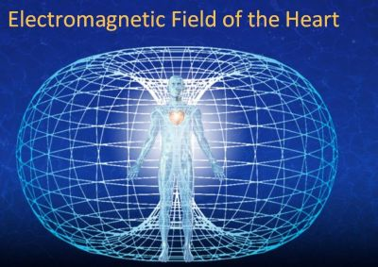

Holding the high frequency of peace encourages others to attune to that frequency. What we know from physics is that energy will entrain to the higher frequency. Have you ever noticed that when someone is upset or angry, they have the power of changing everyone’s mood in the room? The same thing goes for peace. If someone comes in angry or upset, and you hold a strong frequency of peace in their presence, it will be impossible for them to fight or argue with you. In fact, the lower frequencies tend to dissolve before your very eyes. If the person is stubborn or resistant, they will tend to exit and remove themselves from the field.
Some can literally feel the energy of peace emanating from individuals. The field begins to attract more of the same to it. As you hold the peace, others who hold and carry the same frequency will naturally resonate. Once this happens the field gets stronger and amplifies. It’s like playing a radio in stereo, or having the same signal broadcasted from several transmitters at the same time.
This practice is a powerful tool for relationships, families, organizations, communities and the workplace. It’s also a beautiful, benevolent practice for our planet. It’s like a walking meditation, broadcasting peace, full-time, wherever you go. Imagine the collective consciousness of more and more people walking in peace and expanding the field together. It is possible. It is happening. It’s a collective practice of healing circles, meditation groups, enlightened communities and peace organizations around the world.

- Realize Peace on Earth: Participate in Global Shifts Toward a Calm Understanding that Breakdowns Lead to Breakthroughs

When you are fully grounded in the first four strategies, you are ready to be an instrument of peace in the world. Being a calming presence is one thing. But understanding the need and role of that presence is another, which brings us full circle: back to the illusion of separation.
Have you noticed all the chaos and systems crisis occurring in institutions around the world? Government, politics, healthcare, finance, energy, pharmacy, media, and education to name just a few, are all undergoing significant breakdowns and transformation. And what we know about evolution is that crisis and chaos precede change.
Almost every organizational system built in a top-down, dominator model, from the era of separation and control, are breaking down. We no longer trust and support institutions that value control, greed, or dominance. As a collective, we are asking for a world that works for all and that means conscious practices of transparency, responsibility, sustainability, cooperation, care of the planet, and what’s in the greater GOOD of the WHOLE. Healthy leadership and management are challenged to transform and evolve, or become extinct. Conscious businesses and visionary entrepreneurs are emerging everywhere. New initiatives and innovations are surfacing. The breakdown of unhealthy systems is making way for the breakthroughs of a conscious, more peaceful world.
Yet, the breakdowns can cause great stress, fear and anxiety, not only for the systems themselves, but humanity and the world at large. As systems breakdown around us, there’s much uncertainty. We can’t “see” the future and we have very near-sighted vision. We are creating a new path with each step, as we take it.

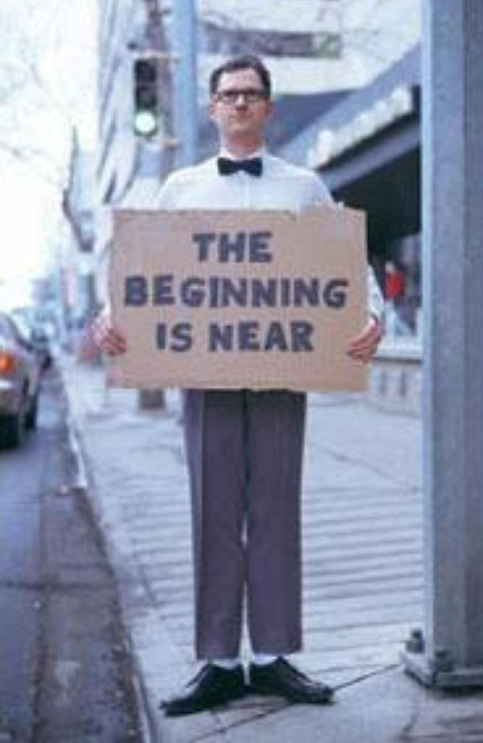

That’s where calm leaders come in. The world needs calm, grounded pillars as we weather the storms of breakdowns and global shifts. We need confident voices to reassure us that good things are emerging and on their way. We need peaceful storytellers who can share what’s working in the world. And we need pioneers of peace who can navigate the turbulent terrain of change.
No matter what your gifts and inspiration, being equipped with an embodied, calm center is the key to effective service. Allow your passion and service to come from this place and watch the transformation within you. Do the inner work. Creating peace on earth begins with creating and maintaining inner peace.
Pay attention to your relationship with yourself. Is it peaceful? Is your self-talk loving, compassionate and encouraging? You will not effectively serve a global agenda without mastering personal inner peace and local peace making. When we embody inner peace it naturally expands out to every situation – personal relationships, family, the workplace (your commute to work), and community. Establish and anchor this inner peace.

Summary

Embodying calm in a world of chaos is a holistic practice available to all who seek to create and sustain inner peace. There are many philosophies, methods, tools and resources available. We can find helpful direction in the fields of science, health, wellness and spirituality. And, combining the best of what’s available takes us directly to the leading edge of consciousness. As we trust the impulse of creation moving through us, we innately become more equipped to deal with the evolution of consciousness and the change and chaos that can go with it.
Next time you find yourself in the middle of a dark storm, remember to breathe and center yourself. The eye of the storm will be revealed and you have everything you need to expand that calm place of inner peace. All is well.

I’m wishing you a world of love,
Julie Krull, Ph.D.

References
Twister: http://www.imdb.com/title/tt0117998/
Lynne McTaggart: http://www.lynnemctaggart.com/
Tich Nhat Hanh: http://plumvillage.org/about/thich-nhat-hanh/
The Dr. Julie Show: All Things Connected: http://www.TheDrJulieShow.com
Relaxation Response/Herbert Benson: http://www.relaxationresponse.org/
HeartMath Institute: http://www.HearthMath.org
Quick Coherence Technique: http://www.heartmath.com/quick-coherence-technique/
Centering Prayer/Father Thomas Keeting: http://www.centeringprayer.com/
Transcendental Meditation: https://www.tm.org/meditation-techniques
GOOD of the WHOLE: http://www.GOODoftheWHOLE.com

